

**INTRODUCTION**

**Hanoi, May 28th, 2020**

**Table of Contents**

**Chapter 1: Introduction** 2

**1.1. Purpose** **2**

**1.2. Project Information** **2**

**1.3. The People** **2**

***1.3.1. Supervisor*** ***2***

***1.3.2. Team Members*** ***2***

**1.4. Background** **3**

***1.4.1. Saving recruitment costs*** ***3***

***1.4.2. Branding channel*** **3**

***1.4.3. Meeting purpose’s candidates*** **3**

**1.5. Literature Review of Existing Systems** **3**

***1.5.1. The Samsung careers (SC)*** **3**

***1.5.2. VinAI Careers*** **4**

**1.6. The Proposal of System** **5**

***1.6.1. System Functions*** **5**

***1.6.2. Business Flows*** **6**

***1.6.2.1 Process of Candidate*** **6**

***1.6.2.2 Process of HrStaff*** ***7***

***1.6.2.3 Process of Admin*** ***7***

***1.6.3. Out-of-scope Functions*** **8**

***1.6.4. Special Approaches*** **8**

# Introduction

## Purpose

This chapter provides an overview of the project including background information, a literature review of the existing system and raising a proposal for ideas of improvement.

## Project information

* Project name: **FPT Education Recruitment System**
* Project code: **FERS**
* Project group name: **PID Team (Productivity Innovation Development Team)**
* Product type: **Web Application**
* Timeline: **From 18th May 2020 to 1st September 2020**

## The people

### Supervisor

|  |  |  |  |  |
| --- | --- | --- | --- | --- |
|  | **Full name** | **Phone** | **E-mail** | **Title** |
| Supervisor | Phan Trường Lâm | 0913507828 | [lampt2@fe.edu.vn](mailto:lampt2@fpt.edu.vn) | Lecturer |

*Table 1.1 – Supervisor’s information*

### Team members

|  |  |  |  |  |  |
| --- | --- | --- | --- | --- | --- |
|  | **Full name** | **Student ID** | **Phone** | **E-mail** | **Role** |
| 1 | Đỗ Văn Tuấn | SE05339 | 0868455987 | [tuandvse05339@fpt.edu.vn](mailto:tuandvse05339@fpt.edu.vn) | Leader |
| 2 | Nguyễn Thái Bảo | SE05601 | 0353754567 | [baontse05601@fpt.edu.vn](mailto:baontse05601@fpt.edu.vn) | Member |
| 3 | Trần Quốc Đạt | SE05715 | 0888833324 | [dattqse05715@fpt.edu.vn](mailto:dattqse05715@fpt.edu.vn) | Member |
| 4 | Bùi Thanh Tùng | SE05661 | 0354442626 | [tungbtse05661@fpt.edu.vn](mailto:tungbtse05661@fpt.edu.vn) | Member |
| 5 | Đỗ Duy Luyện | SE04999 | 0383551655 | [luyenddse04999@fpt.edu.vn](mailto:luyenddse04999@fpt.edu.vn) | Member |

*Table 1.2 – Team member’s information*

## Background

FPT Corp is one of the largest companies in Viet Nam and FPT Education is a very important part of FPT Corp. FPT Education was founded in 1999. Since then, FPT Education has been growing with more than 50 thousands students at 28 training facilities in Ha Noi, Ho Chi Minh, Da Nang, Can Tho, Quy Nhon, Tay Nguyen.

### Why are human resources important ?

Candidates take a lot of time to find a job that they want. For all companies and businesses, the recruitment of personnel is always focused. Because human resources are the foundation of enterprise development[1] . Especially with the key positions of the company. Without them, the operation of the company will be stopped and reduced. According to the assessment, for each company, the human resource plays an extremely important platform.

### Recruitment channels

### Fpt.edu.vn/tuyen-dung

* **Word of mouth**
* **Vietnamworks**

Nowadays, FPT Education still doesn’t have a good Recruitment System. HR still has to send greeting mails by hand, manages CV on Excel. The website is really slow and it is very difficult to manage candidates. The site only has search jobs.

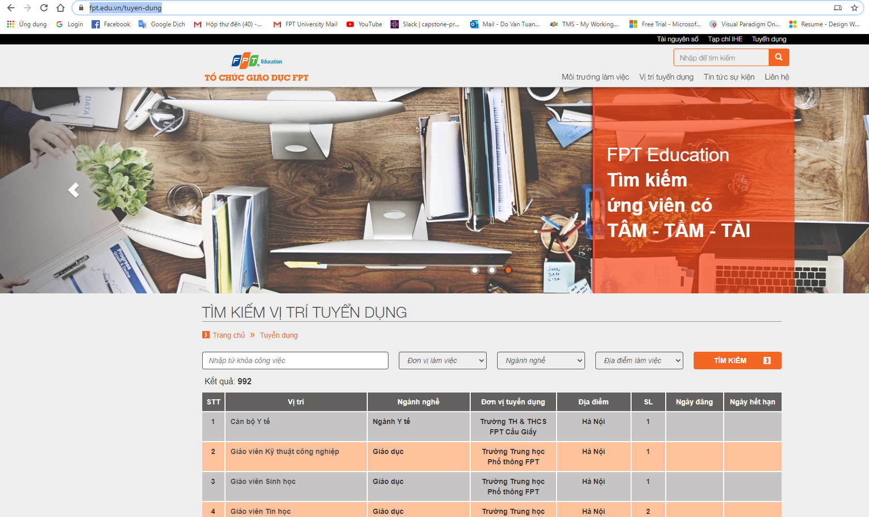

## Literature Review of Existing Systems

This section contains the overview of some existing applications that attempt to tackle limitations of traditional issuing, as well as their advantages..

### The Samsung careers (SC)

SC is a website for hiring people for Samsung’s organizations.

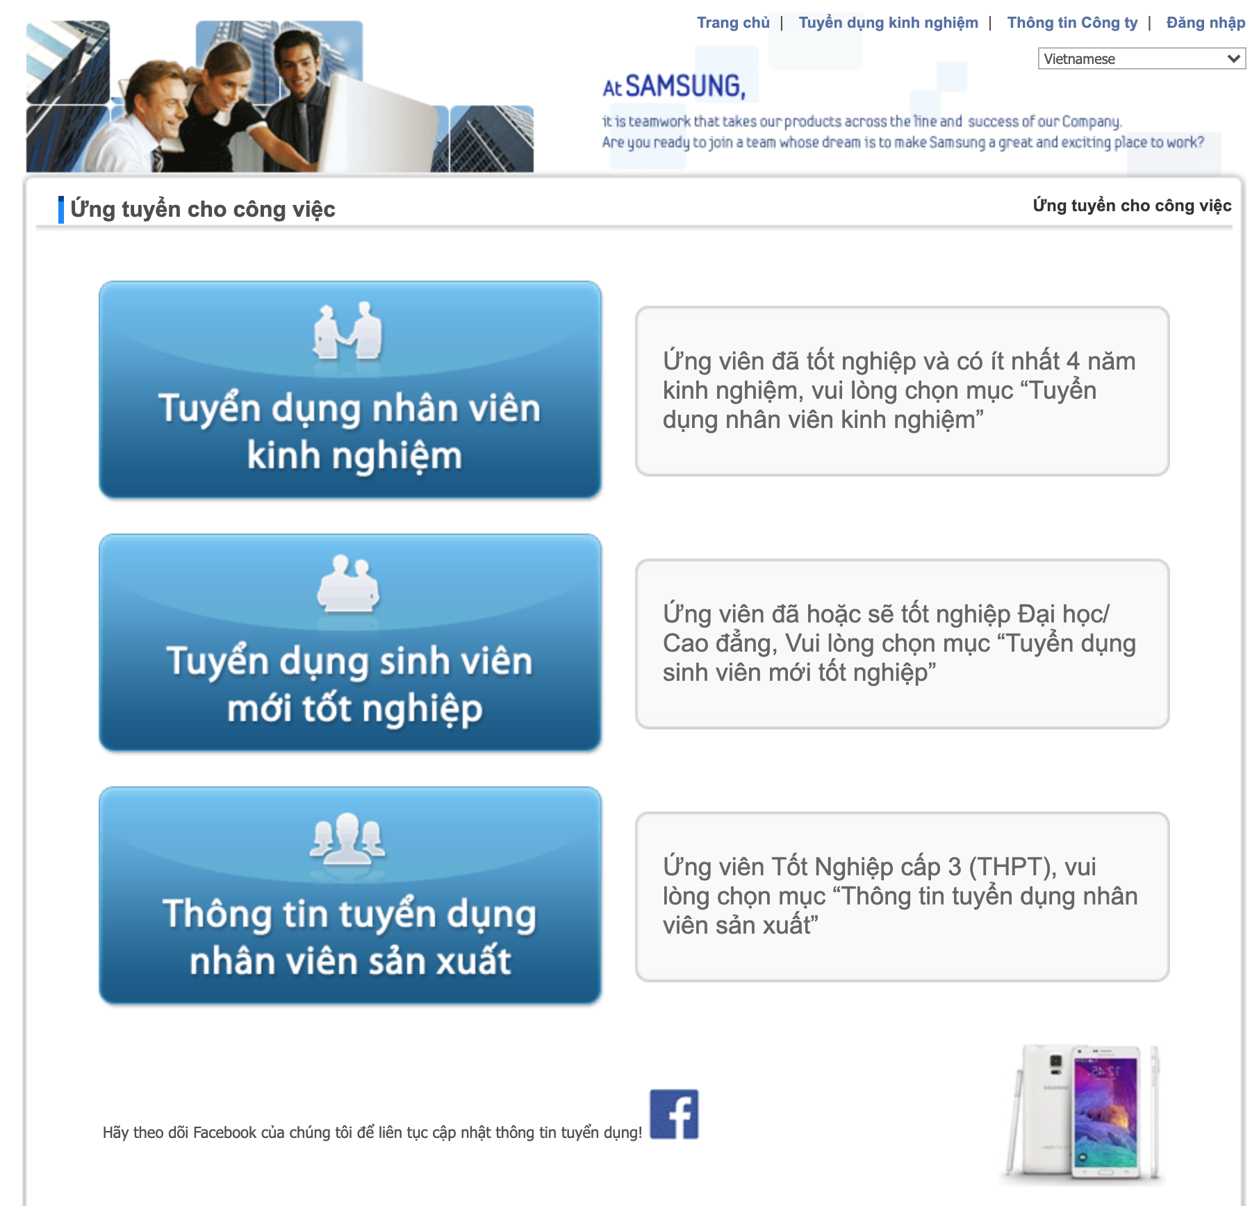

*Figure 1.1 – Example of SC screen*

The advantages and of SC as follow:

|  |
| --- |
| **Advantages** |
| * Allow candidates to search and find jobs and view in detail. * Candidates can research more information about the company. |

*Table 1.3 – Advantages & disadvantages of SC*

### VinAI Careers

VinAI Research is a newly established research lab located in Hanoi, Vietnam. Funded by VinGroup, the largest enterprise in Vietnam by capitalization, their mission is to conduct high-impact research that pushes the knowledge frontier in AI and to accelerate applications of AI in Vietnam, the Asia Pacific region, and beyond.

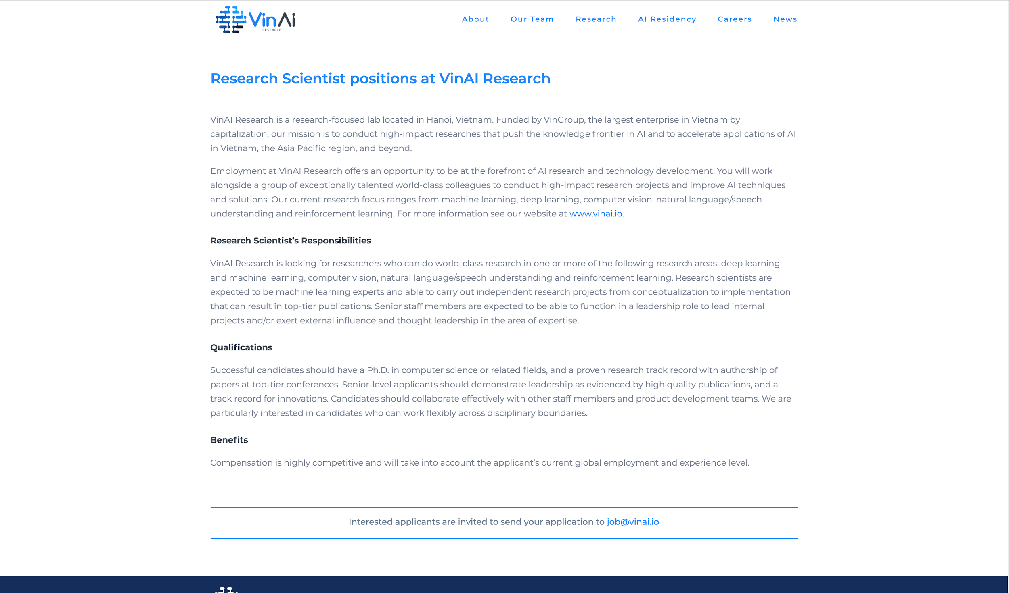

*Figure 1.2 – VinAI Careers screen*

The pros of VinAI Careers are listed as below:

|  |
| --- |
| **Advantages** |
| * VinAI Careers shows jobs information in detail. * Jobs are sorted, candidates can focus easily. |

*Table 1.4 – Advantages & disadvantages of VinAI Careers*

## The proposal of system

From those studies, our group came up with an idea: to build a professional recruiting website for FPT education system

### System functions

There are 3 types of user in **FPT Education Recruitment System:**

|  |  |
| --- | --- |
| **Type of User** | **Description** |
| Candidate | Users who can view all information about organizations, recruitment of FPT Education System and apply to a job |
| HR Staff | Manage all CVs that were uploaded, manage jobs, change status of every cv, export cv to excel and can post, edit, view sending error email of candidate and update information on the website. |
| Admin | Who has the most functionality in the system such as managing locations, accounts, units, careers, config emails, logs, quizzes, questions and question groups. |

*Table 1.5 – Types of user in the FPT Education Recruitment System*

FPT Education Recruitment System will provide the following functions to the above users:

* System allows candidate to view all information about FPT Education and new career
* Candidate can search a career by many keywords
* Candidate can apply for a job
  + If candidate has a CV already, he/she can attach CV file (PDF) and submit to the system
  + If candidate doesn’t have a CV, he/she can create a basic CV and submit to the system
* After successfully uploading CV, the system will send mail notification to candidates that their CVs are uploaded successfully
* If the candidate has not found a suitable job, he/she can leave contact information, HR will contact him/her to advise later .
* Candidates can do a basic test when they apply their CV.
* HR staff can manage all CVs that were uploaded by candidates. That CV will have statuses: new, seen, in process , rejected, approved …
* HR staff can manage quizzes which were sent to the candidate to do a simple quiz to learn more about FPT Education.
* Every status of CV will be managed and processed by HR staff.
* HR staff export list CV to excel format file.
* Admin is a person who has the most functionality in the system such as CRUD
  + Locations
  + Accounts
  + Units
  + Careers
  + Config email
  + Logs
  + Quiz
  + Question
  + Question Group

### Workflows

### Apply job flow of candidate

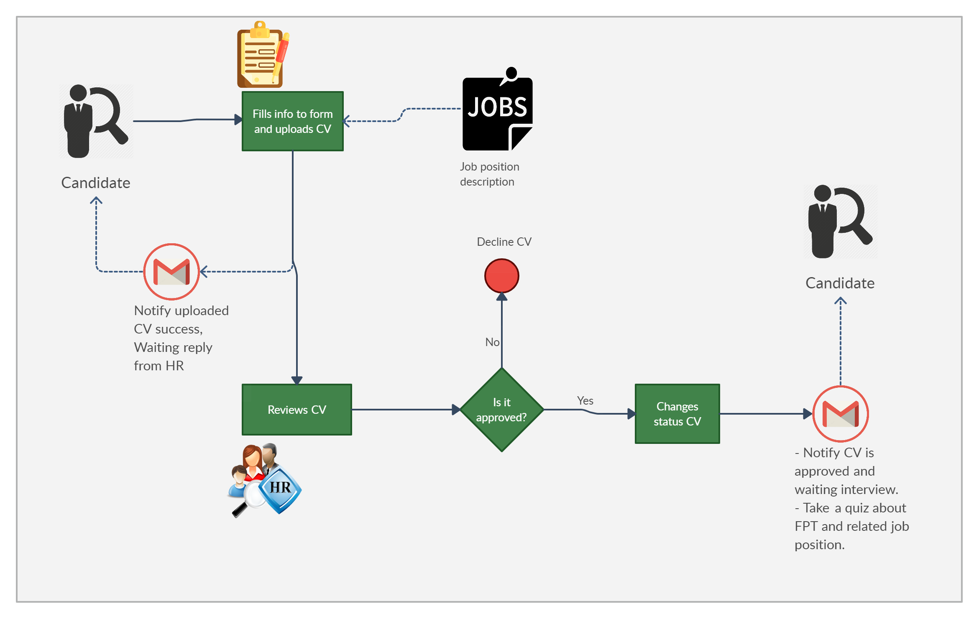

*Figure 1.3 – Apply job flow of candidate*

### Workflow of HR Staff

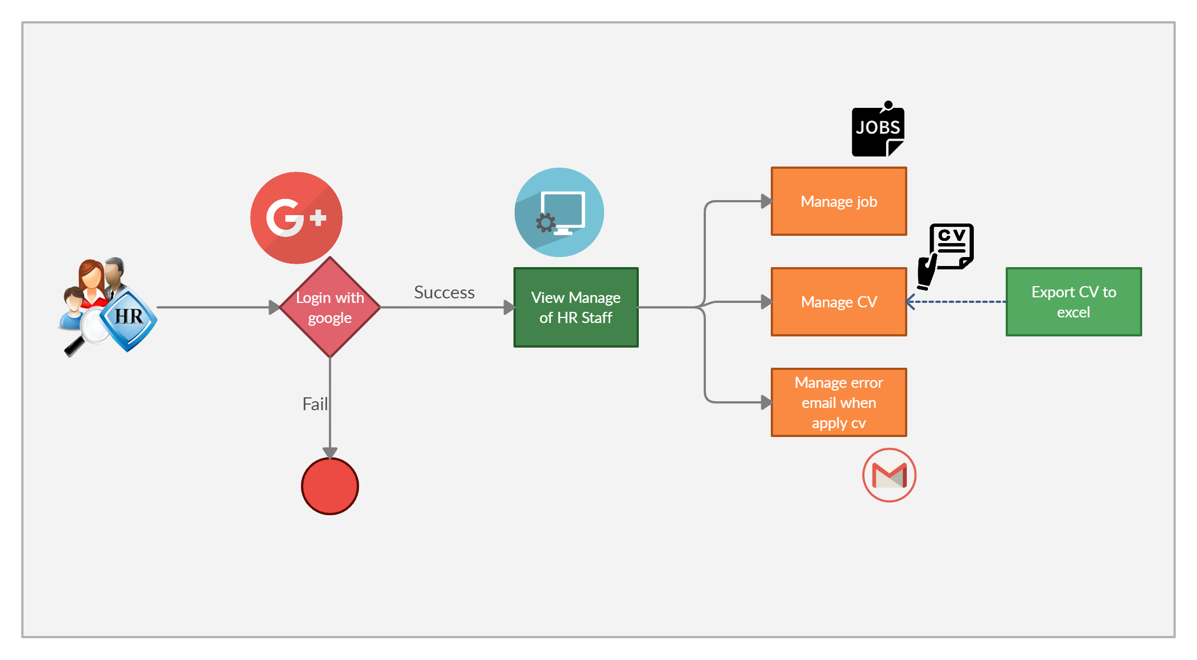

*Figure 1.4 – Workflow of HR Staff*

### Workflow of Super Admin

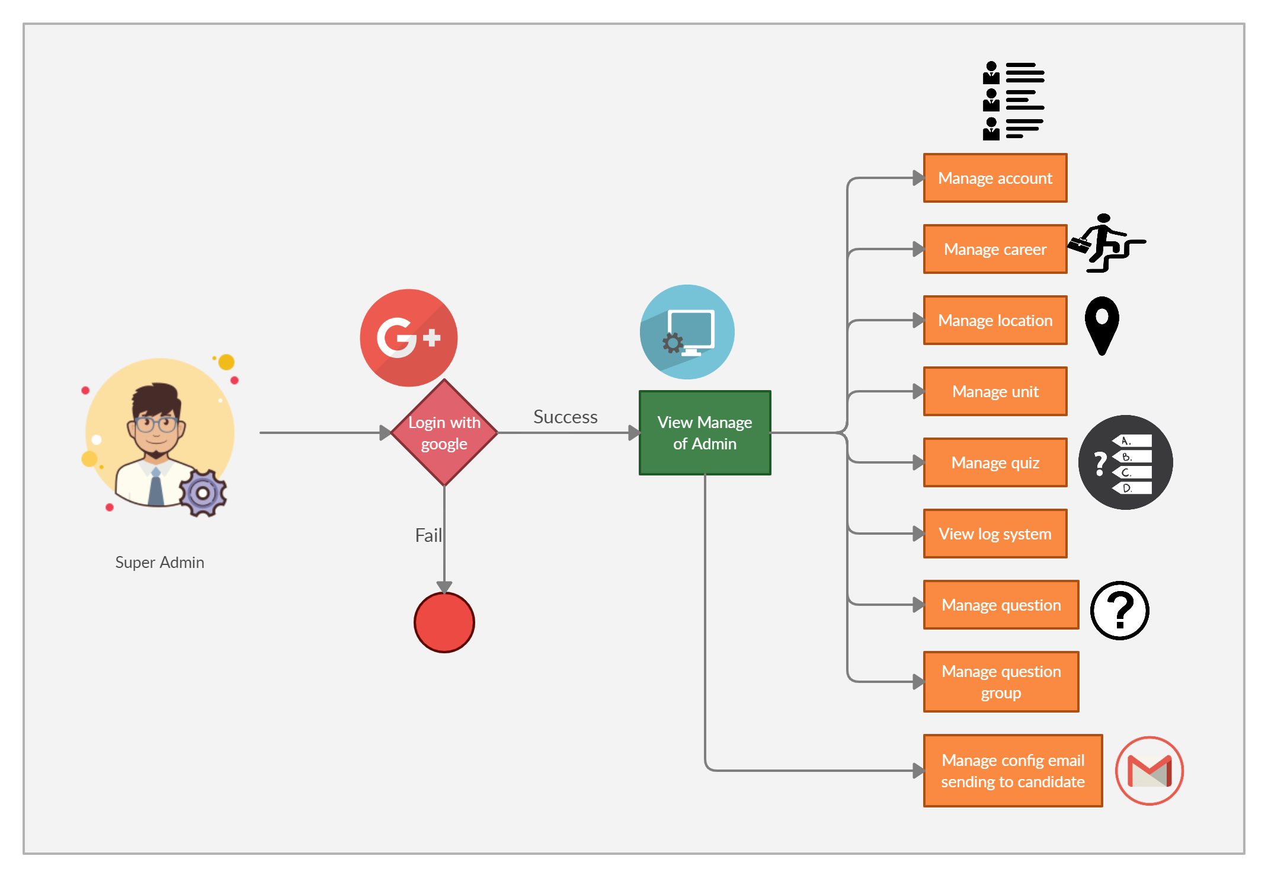

*Figure 1.4 – Workflow of Super Admin*

### Out-of-scope functions

Due to the limitation of time, we will not implement some of the intended functions, although we are aware that they are also important and useful for users of the system:

* Notify to candidates when have new jobs were created in the system if they want
* Integrated chat bot to rep message automatically, reducing the work for the admin
* Use 3D technology to simulate FPT Education workspace environment

### Tools and technique

Finally, we will use some new approaches to solve the stated problems. Having been aware of the emergence of new technologies, we aim at applying them to our project.

* Using .Net MVC Framework[2] and SQL Server to code and build dynamic websites.
* Using Github[3] for managing source code, as well as Continuous Integration and Continuous Delivery (DevOps).
* Using library SmtpClient and MailMessage[4] to automatically send mail to candidates after successfully uploading a CV.

1. Vì sao phải chú trọng về vấn đề tuyển dụng nhân sự: <https://www.farorecruitment.com.vn/vi-sao-phai-chu-trong-van-de-tuyen-dung-nhan-su--t_1/1565>
2. .Net MVC Framework: <https://dotnet.microsoft.com/apps/aspnet/mvc>
3. Github : <https://github.com/marketplace/category/continuous-integration>
4. SmtpClient and MailMessage : <https://docs.microsoft.com/en-us/dotnet/api/system.net.mail.mailmessage>